**Project Planning Phase**

Project Planning Template (Product Backlog, Sprint Planning, Stories, Story points)

|  |  |
| --- | --- |
| Date | 30 October 2022 |
| Team ID | PNT2022TMID45531 |
| Project Name | Nutrition Assistant Application |
| Maximum Mark | 8 Marks |

**Product Backlog, Sprint Schedule, and Estimation (4 Marks)**

The below template to create product backlog and sprint schedule

|  |  |  |  |  |  |  |
| --- | --- | --- | --- | --- | --- | --- |
| **Sprint** | **Functional Requirement** | **User Story Number** | **Task** | **Story Point** | **Priority** | **Team Member** |
| Sprint-1 | Registration | USN-1 | As a Client, I can register for the application by entering my email, password and confirming password. | 9 | High | 1.Mugesh kanna R  2.Murali R  3.Naveen raj A  4.Nivashini.K |
| Sprint-1 | Registration | USN-2 | As a client, I can receive confirmation email once I have registered for the application. | 3 | High | 1.Mugesh kanna R  2.Murali R  3.Naveen raj A  4.Nivashini.K |
| Sprint-2 | Registration | USN-3 | As a Client, I can register for the application Facebook. | 3 | Low | 1.Mugesh kanna R  2.Murali R  3.Naveen raj A  4.Nivashini.K  1.Mugesh kanna R  2.Murali R  3.Naveen raj A  4.Nivashini.K |
| Sprint-1 | Registration | USN-4 | As a Client, I can register for the application by Gmail | 3 | Medium | 1.Mugesh kanna R  2.Murali R  3.Naveen raj A  4.Nivashini.K |
| Sprint-1 | Login | USN-5 | As a Client, I can register for the application by entering email& Password . | 8 | High | 1.Mugesh kanna R  2.Murali R  3.Naveen raj A  4.Nivashini.K |
| Sprint-2 | Dashboard | USN-6 | As a Client, I can register for the application by entering email& password | 10 | High | 1.Mugesh kanna R  2.Murali R  3.Naveen raj A  4.Nivashini.K |
| Sprint-3 | Dashboard | USN-7 | As a Client, I can upload the image of my food in the Dashboard. | 10 | High | 1.Mugesh kanna R  2.Murali R  3.Naveen raj A  4.Nivashini.K |
| Sprint-2 | Dashboard | USN-8 | As a client, I could see my Profile. | 8 | Medium |  |
| Sprint-4 | Dashboard | USN-9 | As a Client, I could update my profile. | 10 | High | 1.Mugesh kanna R  2.Murali R  3.Naveen raj A  4.Nivashini.K |
| Sprint-3 | Dashboard | USN-10 | As a Client, I could view the result of the processed image. | 10 | High | 1.Mugesh kanna R  2.Murali R  3.Naveen raj A  4.Nivashini.K |
| Sprint-4 | Dashboard | USN-11 | As a Client, I Could view my history of search. | 10 | Medium | 1.Mugesh kanna R  2.Murali R  3.Naveen raj A  4.Nivashini.K |

**Project Tracker, Velocity & Burndown Chart: (4 Marks)**

|  |  |  |  |  |  |  |
| --- | --- | --- | --- | --- | --- | --- |
| **Sprint** | **Total Story**  **Points** | **Duration** | **Sprint Start Date** | **Sprint End Date**  **(Planned)** | **Story Points**  **Completed (as on**  **Planned End Date)** | **Sprint Release Date**  **(Actual)** |
| Sprint-1 | 20 | 6 Days | 24 Oct 2022 | 29 October 2022 | 20 | 29 October 2022 |
| Sprint-2 | 20 | 6 Days | 31 Oct 2022 | 5 November 2022 | 20 | 5 November 2022 |
| Sprint-3 | 20 | 6 Days | 7 November 2022 | 12 November 2022 | 20 | 7 November 2022 |
| Sprint-4 | 20 | 6 Days | 14 November 2022 | 19 November 2022 | 20 | 19 November 2022 |

**Velocity:**

Imagine we have a 10-day sprint duration, and the velocity of the team is 20 (points per sprint). Let’s calculate the team’s average velocity (AV) per iteration unit (story points per day).

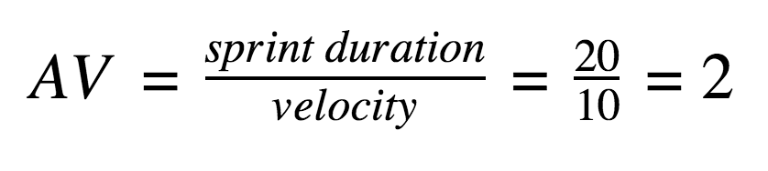

**Burndown** **Chart**:

A burn down chart is a graphical representation of work left to do versus time. It is often used in agile software development methodologies such as Scrum. However, burn down charts can be applied to any project containing measurable progress over time.

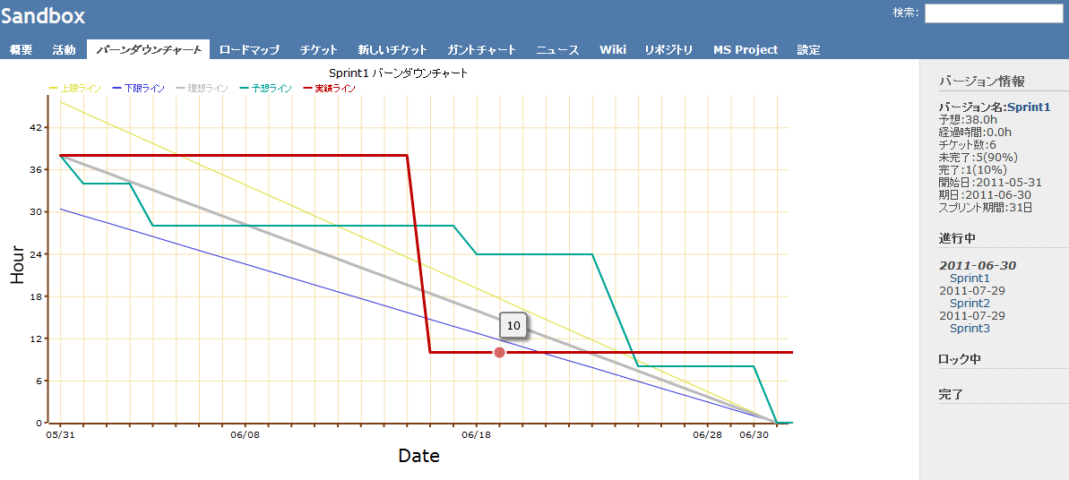

[This Photo](https://forza.cocolog-nifty.com/blog/2011/04/redmine_version.html) by Unknown Author is licensed under [CC BY-SA](https://creativecommons.org/licenses/by-sa/3.0/)